RESOLUTION NO.__________

RE: CERTIFICATE OF APPROPRIATENESS UNDER THE
PROVISIONS OF THE ACT OF THE PENNSYLVANIA
LEGISLATURE 1961, JUNE 13, P.L. 282 (53
SECTION 8004) AND BETHLEHEM ORDINANCE NO.
3952 AS AMENDED.

The applicant proposes to install a hanging sign on the façade at
458 Main St.

NOW, THEREFORE, BE IT RESOLVED by the Council of the City of Bethlehem that a Certificate of Appropriateness is hereby granted for the proposal.

Sponsored by: (s)

(s)

ADOPTED BY COUNCIL THIS DAY OF

(s)
President of Council

ATTEST:

(s)
City Clerk

HISTORICAL & ARCHITECTURAL REVIEW BOARD

The applicant proposes to install a hanging sign on the façade at
458 Main St.

APPLICATION #4:

Peter & Constance LoBaido
1168 W. Tyler St.
Whitehall, PA 18052

OWNER:

__________________________________________________________________________

The Board upon motion by Marsha Fritz and seconded by Diana Hodgson adopted the proposal that City Council issue a Certificate of Appropriateness for the following:

- Sign to be double sided PVC measuring 28” x 36” x 1”.

2. Carved letters with pin stripe on existing hanging brackets.

3. Letters and pin stripe color to be gold or beige with a dark green, brown or black
background.

4. The motion was unanimously approved.

__________________________________________________________________________

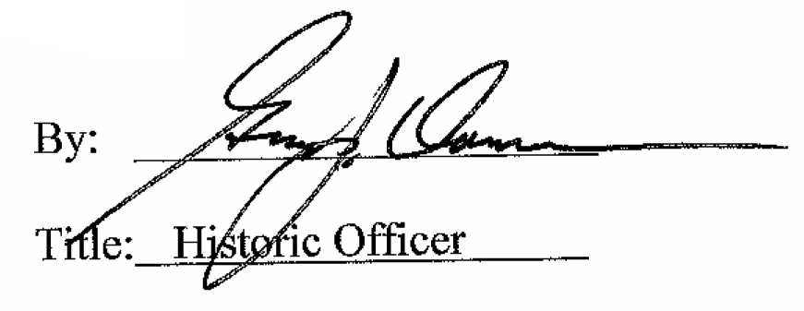

Date of Meeting: May 2, 2018

